Credit Card Approval Prediction
Project Documentation

Project Description
Credit Card Approval Prediction is a Machine Learning-based web application that predicts whether a credit card application is likely to be Approved or Rejected, based on an applicant's personal and financial information. The system helps banks and financial institutions make faster, consistent, and data-driven credit approval decisions by analyzing historical applicant and credit record data.
The application allows users to enter details such as Gender, Age (Date of Birth), Number of Children, Annual Income, Income Type, Education Level, Family Status, Housing Type, Employment Start Date, Occupation Type, and Family Member Count. These inputs are processed and passed to a trained Machine Learning model that predicts the approval status.
The model was trained and evaluated in Google Colab using Python, Pandas, NumPy, and Scikit-learn, then saved with joblib and integrated into a Flask backend. The Flask application provides a simple web interface where a user fills out an application form and instantly receives an Approved or Rejected prediction, making the system fast, lightweight, and easy to deploy.

Scenarios
Scenario 1: A bank officer receives a new credit card application from a salaried employee. After entering the applicant's income, age, employment status, and family details into the system, the model predicts that the application is Approved because the applicant satisfies the eligibility criteria.
Scenario 2: A customer with a short employment history and lower income applies for a card. The model analyses these details against patterns learned from historical credit records and recommends Rejected, helping the bank reduce financial risk.
Scenario 3: A financial institution needs to process many credit card applications every day. Instead of manually reviewing each one, the Credit Card Approval Prediction system automatically evaluates every applicant and returns an instant prediction, reducing processing time and improving decision-making efficiency.

Technical Architecture
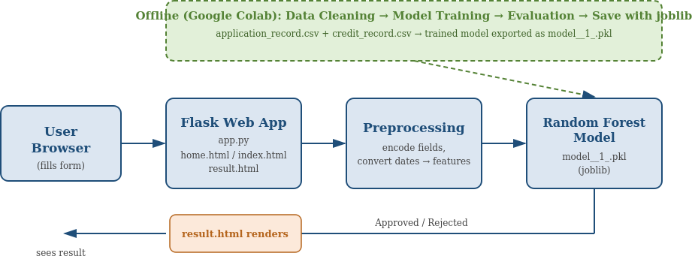
Figure 1: Credit Card Approval Prediction — system architecture
Description: Credit Card Approval Prediction follows a modular Machine Learning architecture. The Flask-based web application provides an intuitive interface where applicants enter their personal and financial details. The backend preprocesses this input (encoding categorical values, converting dates into applicant-age and employment-duration figures) before passing it to a trained Random Forest Classifier. The model analyses the applicant’s attributes and predicts whether the application is likely to be Approved or Rejected. The result is rendered back to the user on a dedicated results page.

Pre-requisites
- Python Programming Knowledge
- Flask Framework
- Machine Learning (Scikit-learn)
- Pandas & NumPy
- Google Colab / Jupyter Notebook
- HTML & CSS
- VS Code
- Credit Card Approval Dataset (application_record.csv, credit_record.csv)

Project Workflow

Milestone 1: Data Collection, Exploration and Cleaning (Google Colab)
In this milestone, we load the raw applicant and credit history data into Google Colab, explore it visually to understand its structure, and clean it so it is ready for feature engineering.

Activity 1.1: Set Up Google Colab and Load the Dataset
- Step 1 — Install Required Libraries: At the top of the notebook, install the libraries used throughout the project:
!pip install pandas numpy matplotlib seaborn scikit-learn xgboost flask
- Step 2 — Import Libraries: Import pandas, numpy, matplotlib, seaborn, and the scikit-learn modules used for modeling:
import numpy as np
import pandas as pd
import matplotlib.pyplot as plt
import seaborn as sns
from sklearn.model_selection import train_test_split
from sklearn.preprocessing import LabelEncoder
from sklearn.linear_model import LogisticRegression
from sklearn.tree import DecisionTreeClassifier
from sklearn.ensemble import RandomForestClassifier
from sklearn.metrics import accuracy_score, confusion_matrix, classification_report
- Step 3 — Upload the Dataset: Use Colab's file upload widget to bring in the two CSV files:
from google.colab import files
uploaded = files.upload()
- Step 4 — Load the CSVs: Read both files into DataFrames:
app = pd.read_csv('application_record.csv')
credit = pd.read_csv('credit_record.csv')
app.head()
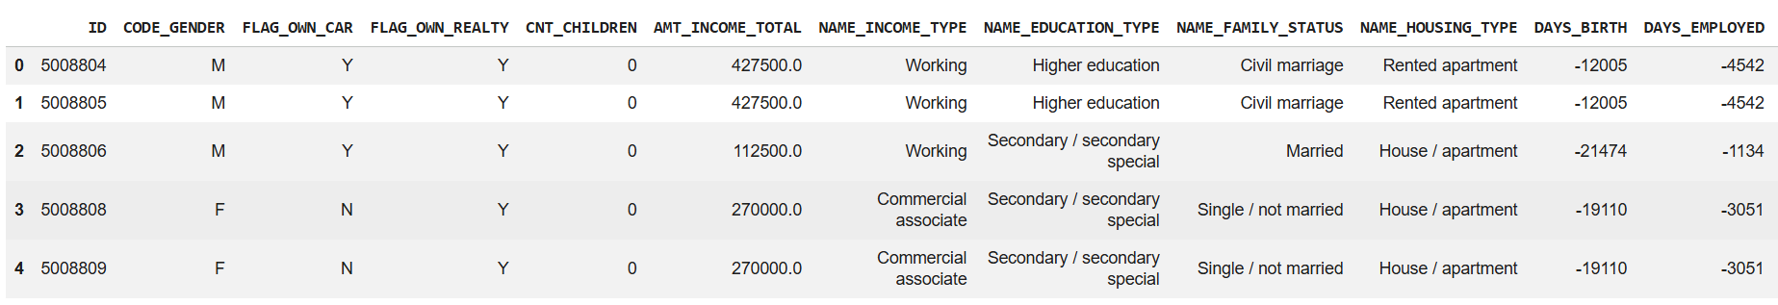
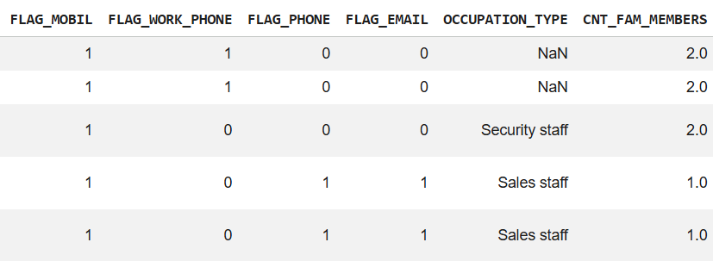
Activity 1.2: Explore the Data (EDA)
- Step 1 — Inspect Structure and Missing Values: Check summary statistics, column types, and missing-value counts:
app.describe()
app.info()
app.isnull().sum()
- Step 2 — Visualize Key Distributions: Plot gender split, income distribution, and occupation/education/family-status breakdowns:
sns.countplot(x='CODE_GENDER', data=app)
plt.title('Gender Distribution'); plt.show()
sns.histplot(app['AMT_INCOME_TOTAL'], bins=30, kde=True)
plt.title('Annual Income Distribution'); plt.show()
- Step 3 — Check Correlations: Build a correlation heatmap over the numeric columns to spot relationships between features:
numeric_app = app.select_dtypes(include=['int64', 'float64'])
corr_matrix = numeric_app.corr()
plt.figure(figsize=(10,8))
sns.heatmap(corr_matrix, annot=True, cmap='coolwarm')
plt.title('Correlation Heatmap'); plt.show()
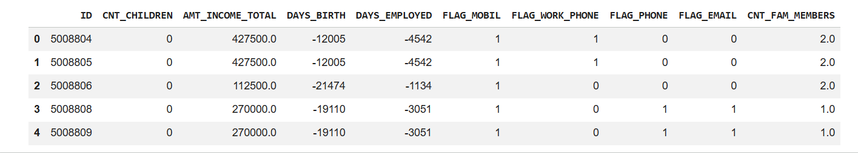
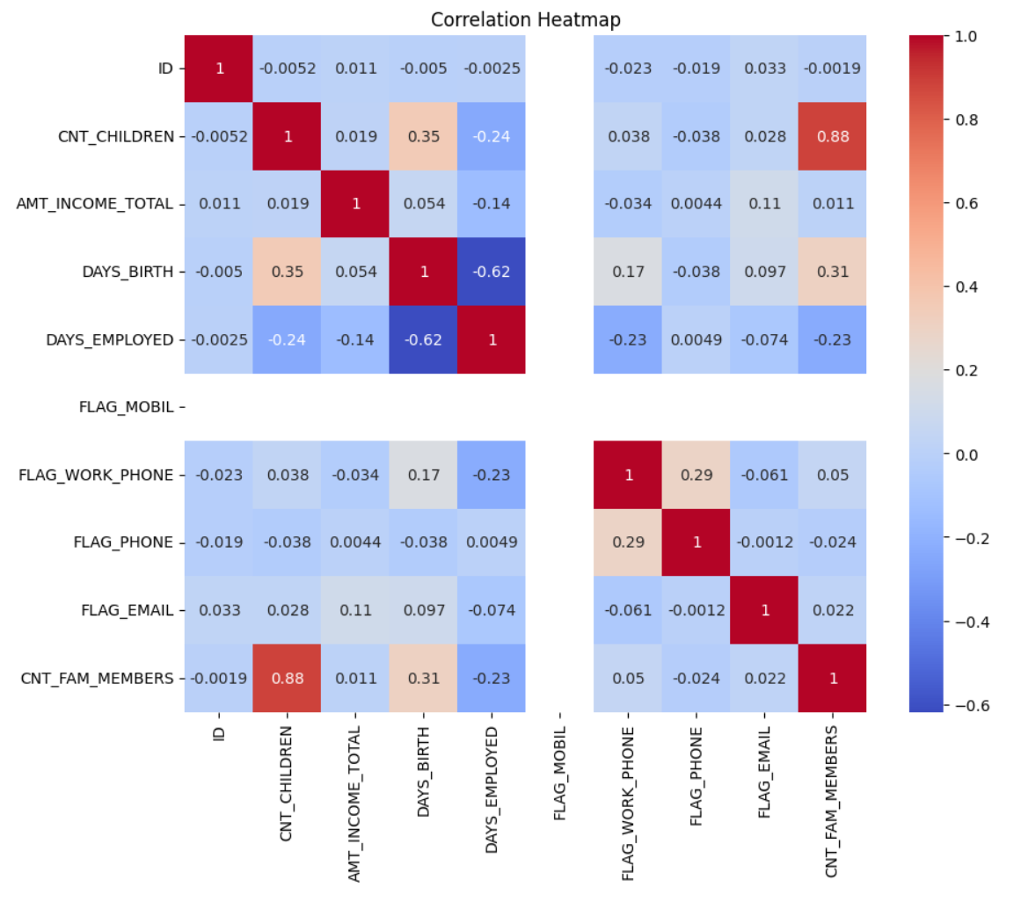

Activity 1.3: Clean the Data
- Step 1 — Remove Duplicate Rows: Drop fully duplicated rows, then drop duplicates based on the full set of applicant columns as a second pass:
app = app.drop_duplicates()
app.drop_duplicates(
subset=['CODE_GENDER','FLAG_OWN_CAR','FLAG_OWN_REALTY','CNT_CHILDREN',
'AMT_INCOME_TOTAL','NAME_INCOME_TYPE','NAME_EDUCATION_TYPE',
'NAME_FAMILY_STATUS','NAME_HOUSING_TYPE','DAYS_BIRTH','DAYS_EMPLOYED',
'FLAG_MOBIL','FLAG_WORK_PHONE','FLAG_PHONE','FLAG_EMAIL',
'OCCUPATION_TYPE','CNT_FAM_MEMBERS'],
keep='first', inplace=True)
- Step 2 — Drop the OCCUPATION_TYPE Column: OCCUPATION_TYPE has a large proportion of missing values, so it is dropped rather than imputed:
app.drop('OCCUPATION_TYPE', axis=1, inplace=True)
print(app.shape)
Activity 1.4: Build the Target Label from Credit History
- Step 1 — Understand the STATUS Column: credit_record.csv has one row per applicant per month. STATUS values are 0-5 (days past due buckets), C (paid off that month), or X (no loan that month).
- Step 2 — Convert STATUS to a Binary Risk Flag: Map C, X, and 0 to 0 (no risk that month), and 1 through 5 to 1 (risk that month):
credit['STATUS'] = credit['STATUS'].replace({
'C': 0, 'X': 0, '0': 0,
'1': 1, '2': 1, '3': 1, '4': 1, '5': 1
})
- Step 3 — Aggregate Per Applicant: Take the maximum STATUS across all of an applicant's months — if they were ever flagged as risky, TARGET becomes 1:
credit_group = credit.groupby('ID')['STATUS'].max().reset_index()
credit_group.head()
- Step 4 — Merge with Applicant Data: Join the aggregated risk flag onto the cleaned applicant table:
df = pd.merge(app, credit_group, on='ID', how='inner')
df.head()
df.shape

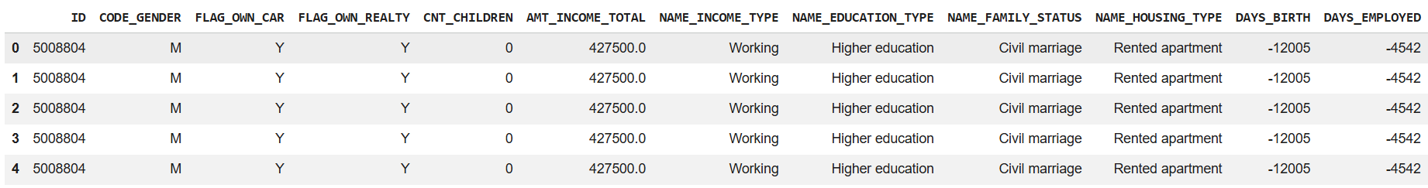

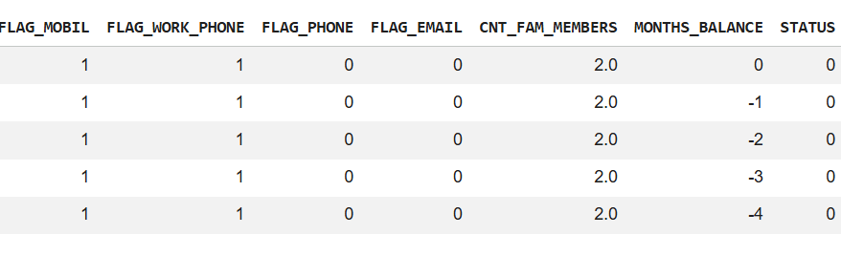
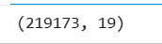

Milestone 2: Feature Engineering and Model Development (Google Colab)
In this milestone, we turn the raw DAYS_BIRTH / DAYS_EMPLOYED fields into readable Age and Years-Employed features, encode the remaining categorical columns, then train and compare several Machine Learning models before saving the best one.
Activity 2.1: Engineer Age and Years-Employed Features
- Step 1 — Make Day Counts Positive: DAYS_BIRTH and DAYS_EMPLOYED are stored as negative numbers, so convert them to positive values first:
df['DAYS_BIRTH'] = abs(df['DAYS_BIRTH'])
df['DAYS_EMPLOYED'] = abs(df['DAYS_EMPLOYED'])
- Step 2 — Derive AGE and YEARS_EMPLOYED: Convert day counts into whole years:
df['AGE'] = (df['DAYS_BIRTH'] / 365).astype(int)
df['YEARS_EMPLOYED'] = (df['DAYS_EMPLOYED'] / 365).astype(int)
- Step 3 — Clean the Unemployed Placeholder: Applicants with no job have a huge placeholder DAYS_EMPLOYED value, which becomes ~1000 years — replace it with 0:
df['YEARS_EMPLOYED'] = df['YEARS_EMPLOYED'].replace(1000, 0)
df.drop(['DAYS_BIRTH', 'DAYS_EMPLOYED'], axis=1, inplace=True)
Activity 2.2: Encode Categorical Features
- Step 1 — Encode Gender, Car and Realty Ownership: Use a separate LabelEncoder per column and print .classes_ to record the mapping:
le_gender = LabelEncoder()
le_car = LabelEncoder()
le_realty = LabelEncoder()
df['CODE_GENDER'] = le_gender.fit_transform(df['CODE_GENDER'])
df['FLAG_OWN_CAR'] = le_car.fit_transform(df['FLAG_OWN_CAR'])
df['FLAG_OWN_REALTY'] = le_realty.fit_transform(df['FLAG_OWN_REALTY'])
print('Gender:', le_gender.classes_)
print('Car:', le_car.classes_)
print('Realty:', le_realty.classes_)
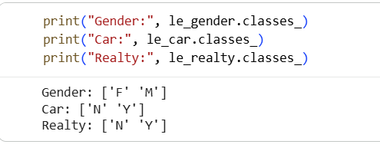

- Step 2 — Encode Income, Education, Family Status and Housing Type: Repeat the same pattern for the remaining categorical columns:
le_income = LabelEncoder()
le_education = LabelEncoder()
le_family = LabelEncoder()
le_housing = LabelEncoder()
df['NAME_INCOME_TYPE'] = le_income.fit_transform(df['NAME_INCOME_TYPE'])
df['NAME_EDUCATION_TYPE'] = le_education.fit_transform(df['NAME_EDUCATION_TYPE'])
df['NAME_FAMILY_STATUS'] = le_family.fit_transform(df['NAME_FAMILY_STATUS'])
df['NAME_HOUSING_TYPE'] = le_housing.fit_transform(df['NAME_HOUSING_TYPE'])
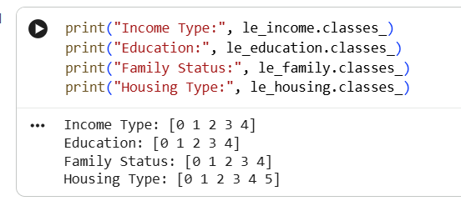
Activity 2.3: Prepare the Train-Test Split
- Step 1 — Define X and y: Drop STATUS and ID from the features; STATUS becomes the target:
X = df.drop(['STATUS', 'ID'], axis=1)
y = df['STATUS']
- Step 2 — Split the Data: Hold out 20% of the data for testing:
X_train, X_test, y_train, y_test = train_test_split(
X, y, test_size=0.2, random_state=42)
Activity 2.4: Compare Multiple Models
Before settling on a final model, three algorithms were trained on the same split and compared on accuracy.
- Step 1 — Logistic Regression (Baseline): A simple linear baseline model:
lr = LogisticRegression(max_iter=1000)
lr.fit(X_train, y_train)
print('Accuracy:', accuracy_score(y_test, lr.predict(X_test)))
- Step 2 — Decision Tree: A single tree-based model for comparison:
dt = DecisionTreeClassifier(random_state=42)
dt.fit(X_train, y_train)
print('Decision Tree Accuracy:', accuracy_score(y_test, dt.predict(X_test)))
- Step 3 — Random Forest: An ensemble of 100 trees, which performed best overall and was selected for deployment:
rf = RandomForestClassifier(n_estimators=100, random_state=42)
rf.fit(X_train, y_train)
print('Random Forest Accuracy:', accuracy_score(y_test, rf.predict(X_test)))
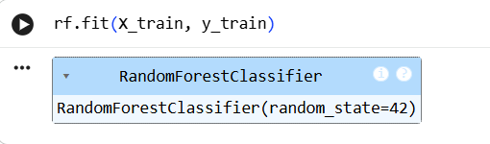
Activity 2.5: Train, Evaluate and Save the Final Model
- Step 1 — Fit the Final Random Forest: Train the chosen model on the full training split:
rf_model = RandomForestClassifier(n_estimators=100, random_state=42)
rf_model.fit(X_train, y_train)
- Step 2 — Evaluate on the Test Set: Check the final accuracy, confusion matrix, and classification report:
y_pred = rf_model.predict(X_test)
print('Accuracy:', accuracy_score(y_test, y_pred))
print(confusion_matrix(y_test, y_pred))
print(classification_report(y_test, y_pred))
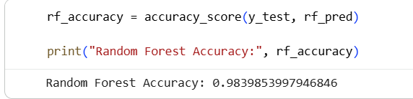
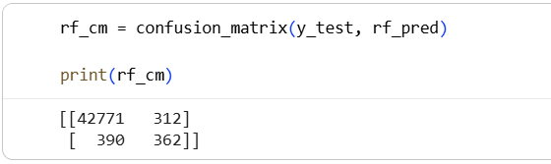
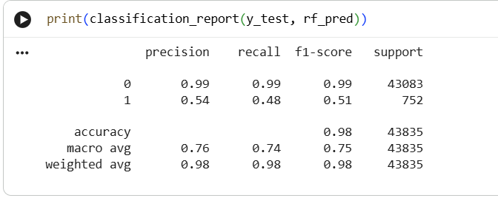
- Step 3 — Save the Model with joblib: Export the trained model so the Flask app can load it later:
import joblib
joblib.dump(rf_model, 'model.pkl')

Note: The final Colab pipeline engineers AGE and YEARS_EMPLOYED (and drops OCCUPATION_TYPE), while app.py's preprocess_form() currently builds DAYS_BIRTH / DAYS_EMPLOYED and still includes OCCUPATION_TYPE. Before your final demo, double-check that the feature list and order in app.py exactly match the columns used to train model.pkl — otherwise predictions may be based on misaligned inputs

Milestone 3: Flask Backend Development (VS Code)
In this milestone, we build the Flask web server that loads the trained model and turns it into an interactive prediction tool.
Activity 3.1: Set Up the Project Structure
- Step 1 — Create the Project Folder: Create a folder (e.g. credit_app) containing app.py, model__1_.pkl, and a templates/ folder for HTML files.
- Step 2 — Create a Virtual Environment: Open a terminal in VS Code and set up an isolated environment:
python -m venv venv
venv\Scripts\activate (Windows)
pip install flask scikit-learn pandas numpy joblib
Activity 3.2: Load the Trained Model
- Step 1 — Rename/Place the Model File: Colab saves the model as model.pkl — download it and place it in the credit_app folder as model__1_.pkl (or update MODEL_PATH in app.py to match whichever filename you use).
- Step 2 — Import joblib in app.py: At the top of app.py, import Flask and joblib:
from flask import Flask, render_template, request
import joblib
- Step 3 — Load the Model at Startup: Load model__1_.pkl once when the server starts, so every request reuses the same in-memory model:
MODEL_PATH = 'model__1_.pkl'
model = joblib.load(MODEL_PATH)
Activity 3.3: Define Encoding Maps and the Preprocessing Function
- Step 1 — Recreate the Training Encodings: Define dictionaries that match exactly the LabelEncoder mappings used in Colab (e.g. GENDER_MAP, INCOME_TYPE_MAP, EDUCATION_MAP, and so on).
- Step 2 — Write preprocess_form(): Write a function that reads the submitted form fields, converts Date of Birth / Employment Date into day-offsets, and returns a NumPy feature array in the same column order as FEATURE_COLS.
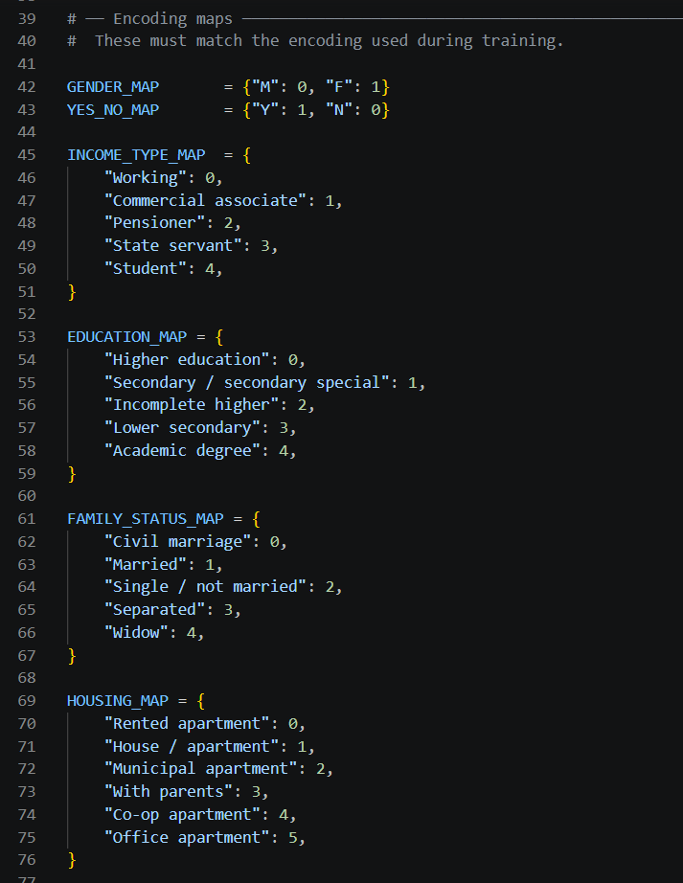
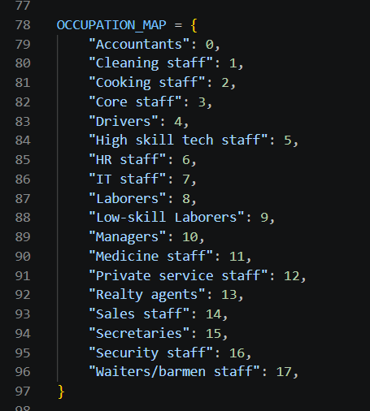
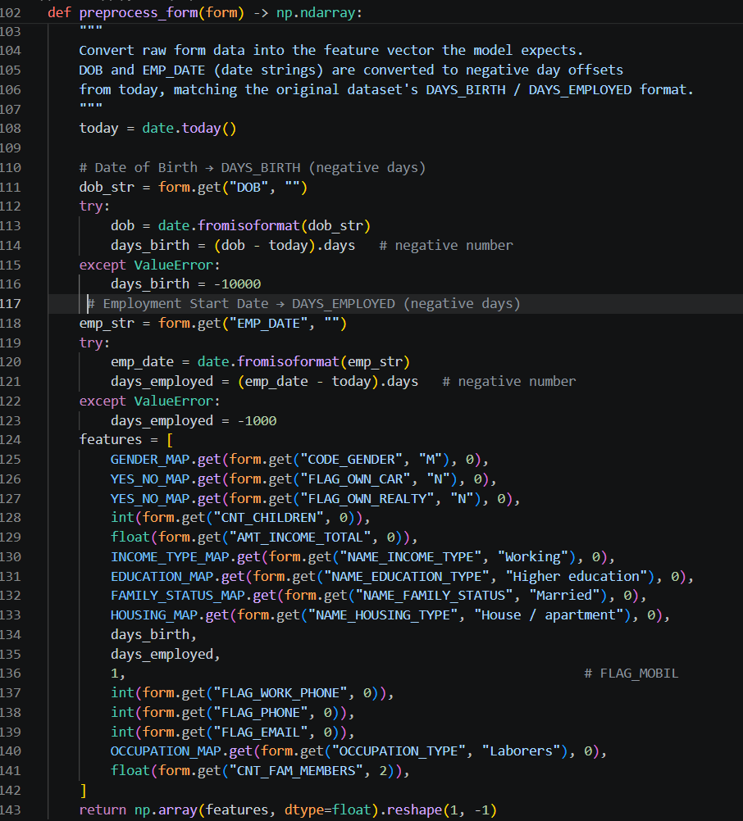
Activity 3.4: Define the Flask Routes
- Step 1 — Home Route: Add a route for the landing page:
@app.route('/')
def home():
return render_template('home.html')
- Step 2 — Form Route (GET): Add a route that displays the empty application form:
@app.route('/predict', methods=['GET'])
def predict_form():
return render_template('index.html')
- Step 3 — Prediction Route (POST): Add a route that receives the submitted form, preprocesses it, runs the model, and renders the result:
@app.route('/predict', methods=['POST'])
def predict():
features = preprocess_form(request.form)
prediction = model.predict(features)[0]
result = 'Approved' if int(prediction) == 1 else 'Rejected'
return render_template('result.html', result=result)

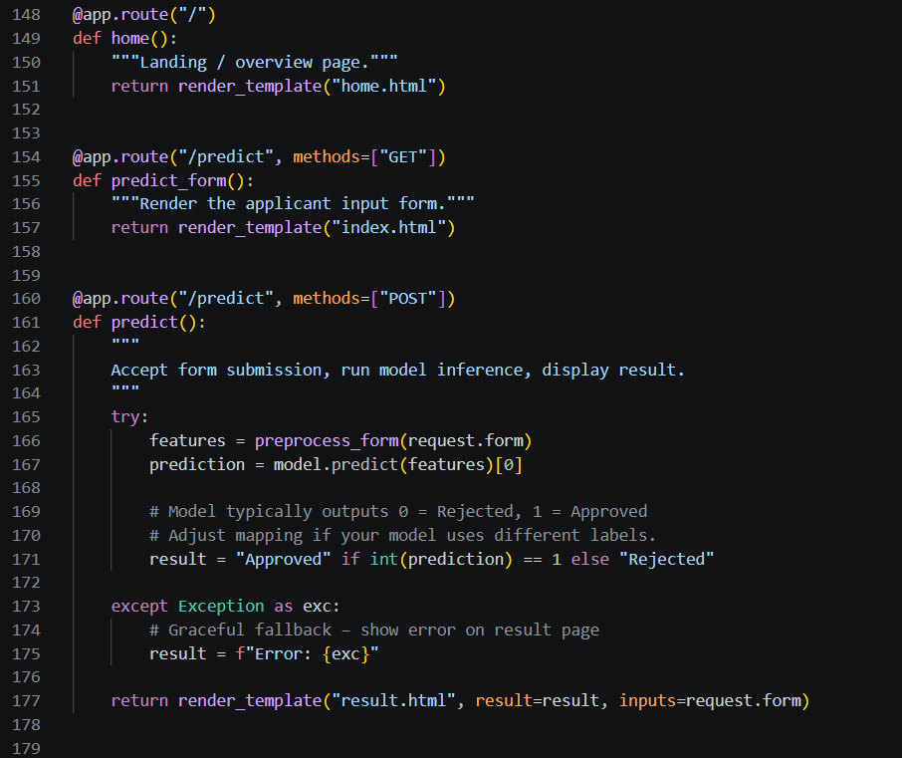

Milestone 4: Frontend Development
In this milestone, we design the three web pages the user actually sees and interacts with.
Activity 4.1: Build the Home Page (home.html)
- Step 1 — Write the Landing Page Content: Introduce the project with a short title and description of what the tool does.
- Step 2 — Style It: Add CSS (inline <style> or a static stylesheet) — a card layout with a gradient background works well.
- Step 3 — Add a Call-to-Action Button: Add a button/link that takes the user to /predict to start an application.
Activity 4.2: Build the Application Form (index.html)
- Step 1 — Add Form Fields: Create input fields for every attribute the model expects: Gender, Own Car, Own Realty, Children Count, Income, Income Type, Education, Family Status, Housing Type, Date of Birth, Employment Date, Occupation Type, and Family Member Count.
- Step 2 — Use Dropdowns for Categorical Fields: Use <select> dropdowns for fields like Income Type and Education, with option values matching the encoding maps in app.py exactly.
- Step 3 — Style the Form: Apply consistent styling matching the home page so the experience feels like one connected app.
Activity 4.3: Build the Result Page (result.html)
- Step 1 — Display the Prediction Prominently: Show 'Approved' or 'Rejected' as a large, clearly colored heading (e.g. green for Approved, red for Rejected).
- Step 2 — Show a Summary: Optionally echo back a summary of the details the applicant submitted.
- Step 3 — Add a Try Again Link: Add a button/link back to /predict so the user can submit another application.

Milestone 5: Testing and Deployment
In this milestone, we verify the application works correctly end-to-end and make it available to run or share.
Activity 5.1: Local Testing
- Step 1 — Start the Server: Run the app from the terminal:
python app.py
- Step 2 — Open It in a Browser: Navigate to http://127.0.0.1:5000/ and click through to the form.
- Step 3 — Test Multiple Applicants: Submit a few different sample applicants — vary income, employment length, and family status — to confirm you can get both Approved and Rejected outcomes.
Activity 5.2: Fix Issues Found During Testing
- Step 1 — Model Loading Errors: If you see an unpickling error when loading the model, make sure app.py uses joblib.load() (not plain pickle.load()) to match how the model was saved.
- Step 2 — Version Warnings: InconsistentVersionWarning from scikit-learn (training vs. local version mismatch) is safe to ignore for a student/demo project, but note it in your documentation.
- Step 3 — Input Validation: Wrap the prediction logic in a try/except so malformed form input doesn't crash the server.
Activity 5.3: Deployment
- Step 1 — Local Deployment: For a class demo, running python app.py and presenting from http://127.0.0.1:5000/ is sufficient.
- Step 2 — (Optional) Public Deployment: To share a live link, deploy to a free platform like Render or PythonAnywhere, or use Ngrok to tunnel your local server to a public URL for a temporary demo.

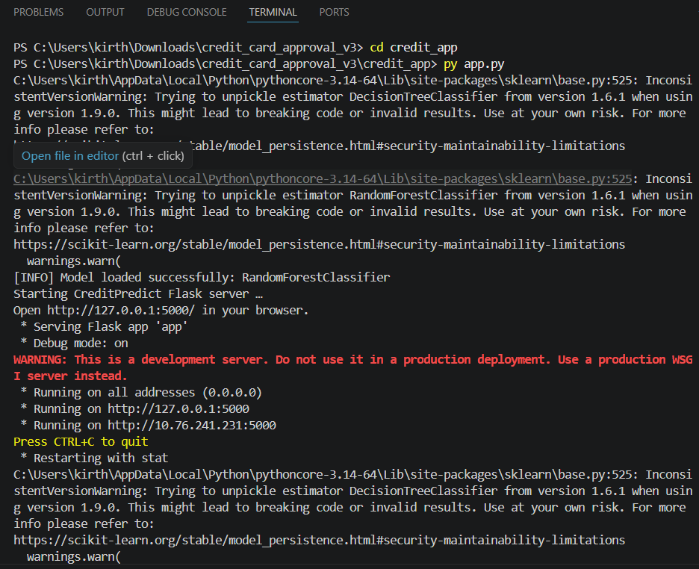

Milestone 6: Documentation and Conclusion
Activity 6.1: Prepare Documentation
Prepare this project documentation, including the architecture diagram, detailed workflow, and screenshots of every page and notebook step.
Activity 6.2: Present the Project
Present the final Credit Card Approval Prediction system, demonstrating the Colab training workflow, the Flask application, and the model's performance.

Exploring the Website's Web Pages

Home Page
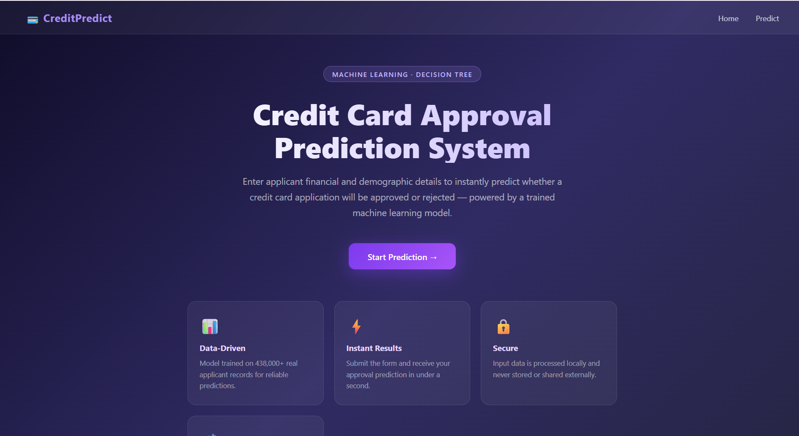 Description: The landing page introduces the Credit Card Approval Prediction project and provides a button/link that takes the user to the application form.

Application Form Page
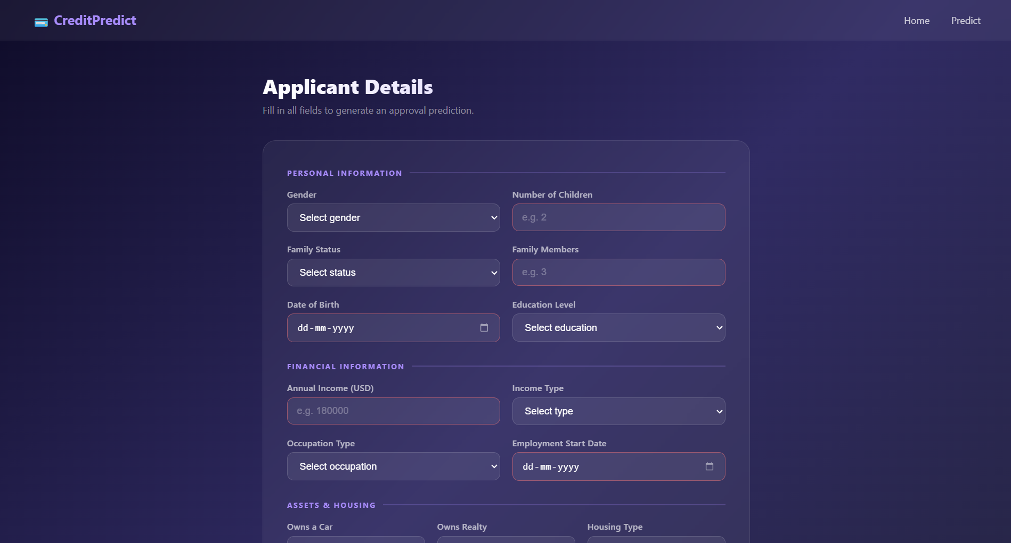
Description: This page contains the applicant details form — gender, income, income type, education, family status, housing type, date of birth, employment start date, occupation type, and family member count — with a Submit button that sends the data to the model for prediction.

Result Page 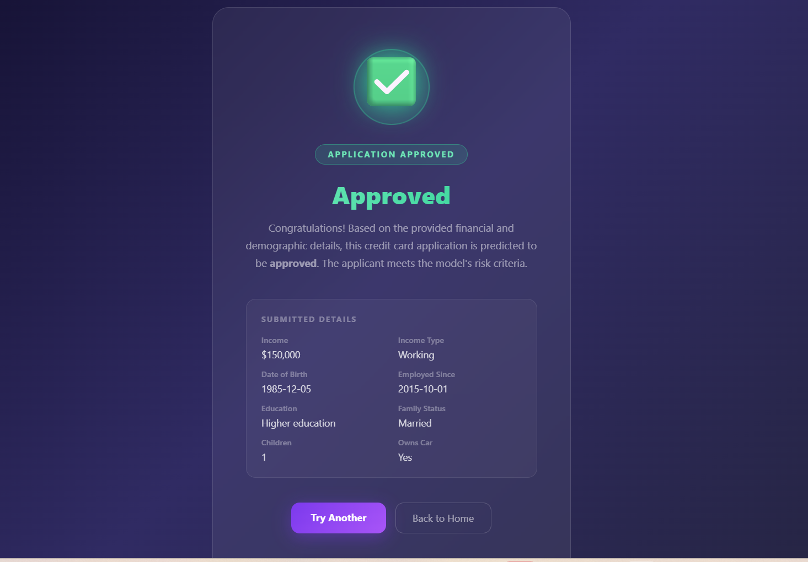

Description: This page displays the model's prediction (Approved or Rejected) along with a summary of the details the applicant submitted.

Conclusion
The Credit Card Approval Prediction system provides an efficient, intelligent solution for predicting whether a credit card application is likely to be approved or rejected using Machine Learning. By analyzing applicant information such as income, employment status, family status, and housing type, the system helps financial institutions make faster, more consistent, and less biased credit decisions. Built using Google Colab for model development and Flask for deployment, the project demonstrates a practical, lightweight, end-to-end Machine Learning application — from raw data to a usable web interface — and highlights how such tools can support data-driven decision-making in the banking and financial sector.

